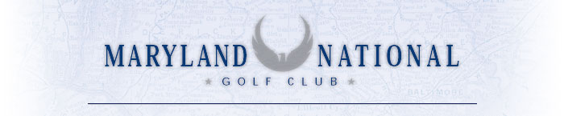

Corporate Meeting
Menu

Light Breakfast Buffets

Coffee, Bagels & Doughnuts $7.50 per person

The Continental $13.95 per person
- A basket of breakfast pastries, bagels and muffins with jams and jellies
- Seasonal fresh fruit and breakfast cereal
- Choice of two breakfast juices: orange juice, grapefruit, tomato, apple, or cranberry
- Freshly brewed coffee, decaffeinated coffee, and tea.

Full Breakfast Buffet

South Mountain Breakfast Buffet $16.95 per person
- Fluffy country fresh scrambled eggs
- Applewood bacon and country sausage
- Yukon golden breakfast potatoes
- Pastries/bagels with accompaniments
- Coffee and juices.

All Day Beverage Station
$7.00 per person
Beverage station set up in your meeting room and replenished throughout the day. Includes coffee and assorted teas, bottled sodas, iced tea and water.

Afternoon Snacks
$5.00 per person
Pretzels, potato chips, freshly baked cookies and brownies.

Lunch Buffet

The Arthur Hills Buffet $17.95 per person

Assortment of sliced smoked turkey and glazed ham, and

your choice of tuna or chicken salad

Assorted sliced cheeses, fresh breads, rolls and condiments

Tossed garden salad, creamy coleslaw and country potato salad

Freshly baked cookies and brownies

A La Carte Lunch options are available from our rotating menu.

Desserts

Your server will present an assortment of the day’s selections
Ranging in price from $5.95 - $7.95

Groups providing their own cake will be charged a flat rate fee of $25
Maryland National will provide skirted catering table,
cake cutting service, plates, and forks.

Customized menus can be specially created for your event.

We hope to have the opportunity to help you plan a successful
meeting day or retreat.

